CRANK-NICHOLSON DIFFERENCE METHOD:
AIM:
To solve the parabolic equation
u_{xx}=au_{t} with boundary conditions
u(0,t)=T₀, u(ℓ,t) =T _{ℓ} and the initial condition u(x,0) = f(x)
The equation to be solved is u_{xx}=au_{t} ….(1)
At u_{i,j’}
u_{xx}= 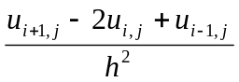
And at u_{i, j+1,}
u_{xx}= 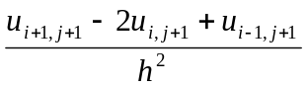
Taking the average of these two values,
u_{xx} = 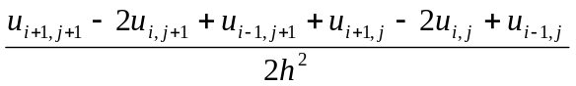
Using u_{t} = 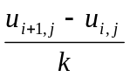, equation (1) reduces to
= a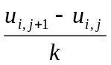
Setting 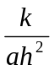= λ, the above equation reduces to
…(I)
This can be rewritten as,
λ (u_{i+1,j+1} + u_{i-1,j+1}) -2 (λ+1 )u_{i,j+1} = 2 (λ-1) u_{i,j} –λ (u_{i+1,j} + u_{i-1,j}) ….(I)
Equation (I) is called crank-Nicholoson difference scheme or method.
PROBLEMS:
- .Solve by Crank-Nicholson method the equation u_{xx} = u_{t} subject to u(x,0) = 0,
u(0,t) = 0 and u(1,t) = t, for two time steps.
Sol:
x ranges from 0 to 1. take h = ; here a = 1
k = ah² to use simple form
k = 1 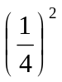 = 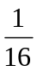
We use
u_{i,j+1}=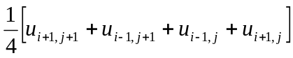 …….(1)

t \ x | 0 | 0.25 | 0.5 | 0.75 | 1
0  1\16 | 0  0 | 0  u₁ | 0  u₂ | 0  u₃ | 0  1\16
Let the unknowns be represented by u₁,u₂,u₃,…….
The boundary conditions are marked in the table against t = 0, x = 0 and x = 1.
Using the scheme(1),
u₁=(0+0+0+u₂)=u₂ …………(2)
u₂=(0+0+u₁+u₃)=(u₁+u₃) ………….(3)
u₃=(0+0+u₂+)=(u₂+ ) …………(4)
Solving the three equations given by (2), (3), (4) we get u₁, u₂, u₃.
u₁ = 0.0011, u₂ = 0.0045 , u₃ = 0.0168.

- Using Crank-Nicholson’s scheme ,solve u_{xx}=16u_{t}, 0 < x < 1, t > 0 given
u(x,0) = 0, u(0,t) = 0, u(1,t) = 100t.
Compute u for one steps in t direction taking h =
Sol:
Here a = 16, h = .
k = ah² = 16 () = 1
u_{i,j+1} = [u_{i+1,j+1} + u_{i-1,j+1} + u_{i+1,j} +u_{i-1,j}] ------------(1)

t \ x | 0 | 0.25 | 0.5 | 0.75 | 1
0  1 | 0  0 | 0  u₁ | 0  u₂ | 0  u₃ | 0  100

u₁=(0+0+0+u₂)=u₂ …………(2)
u₂=(0+0+u₁+u₃)=(u₁+u₃) ………….(3)
u₃=(0+0+u₂+100)=(u₂+100) …………(4)
Solving the three equations given by (2), (3), (4) we get u₁, u₂, u₃.
u₁ = 1.7851, u₂ = 7.1429 , u₃ = 26.7857

